Azure Site Backup and Recovery

Cameron Robinson

Here you see images of my creation of my vm.

I have set my target region to West US 2.

Here are advanced settings to make sure the recovery is done in the west us2 region along with other settings.

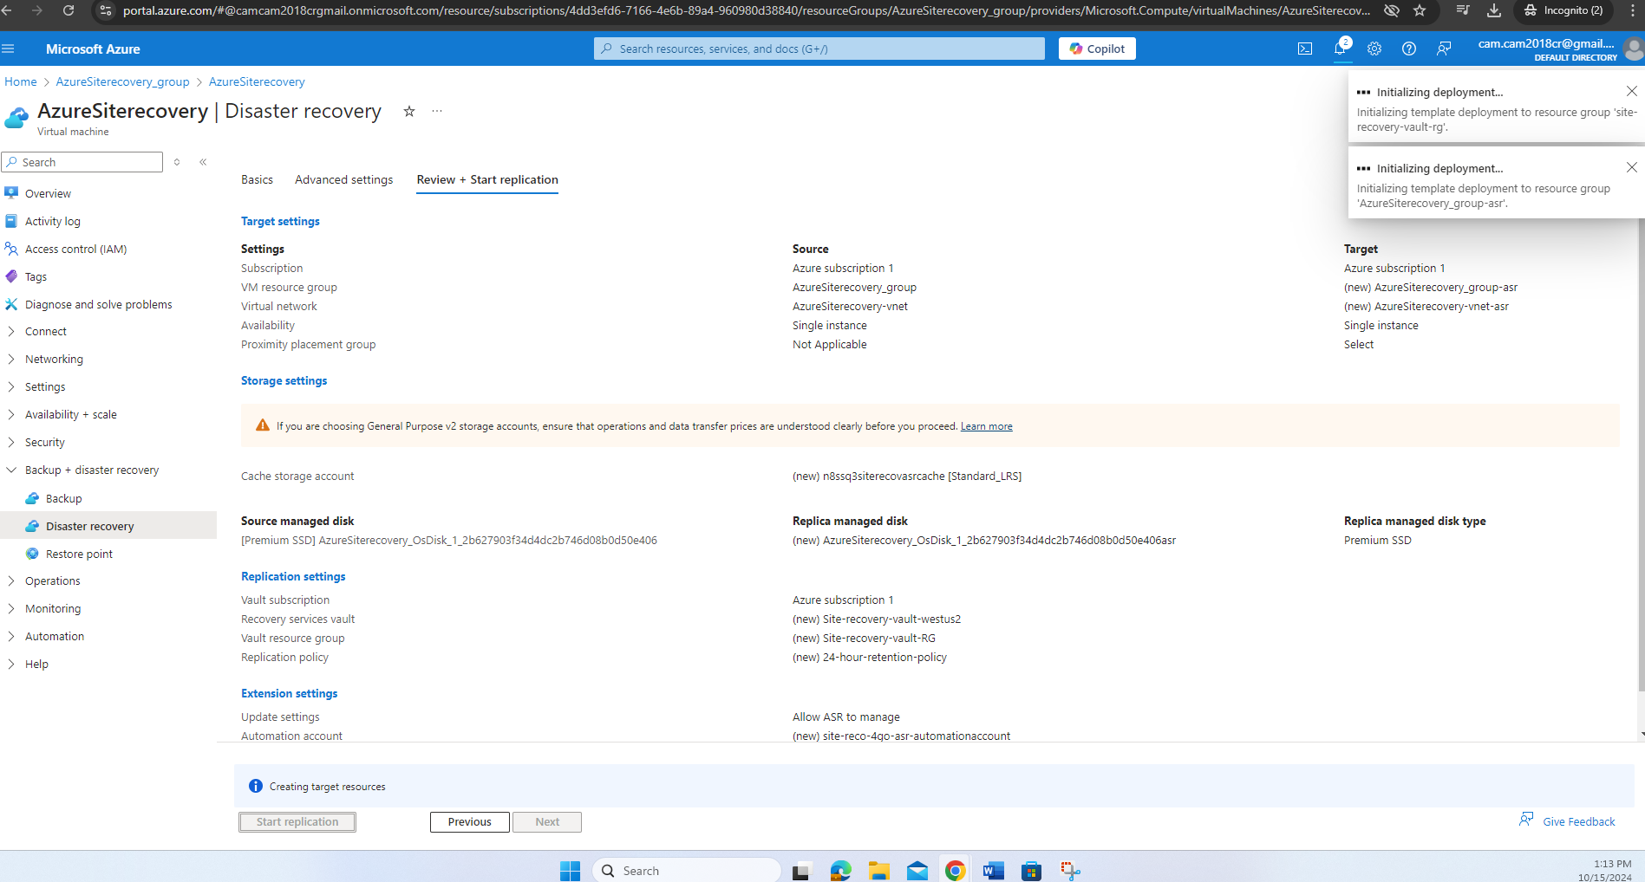

I have now initiated replication.

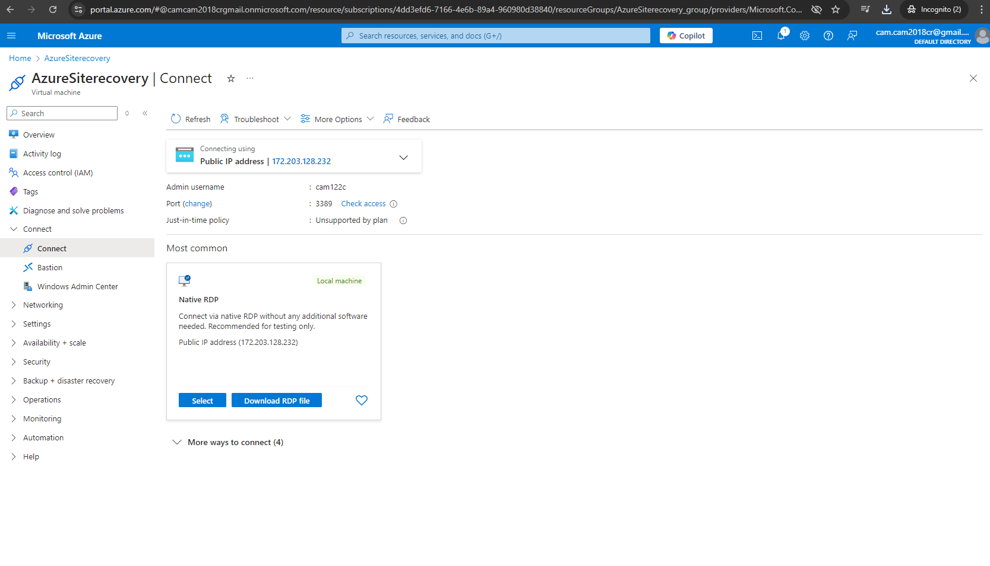

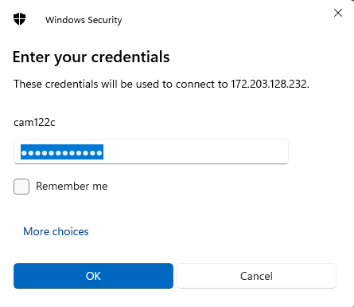

To connect to my VM. I need to enter the credentials I have set when I was created my VM.

Here is a screenshot of me successfully connecting my VM.

In order to have my website public successful with my VM. I must install IIS Server on my VM. I will use the IP address that is associated with my VM to enter in the Server manager when installing IIS.

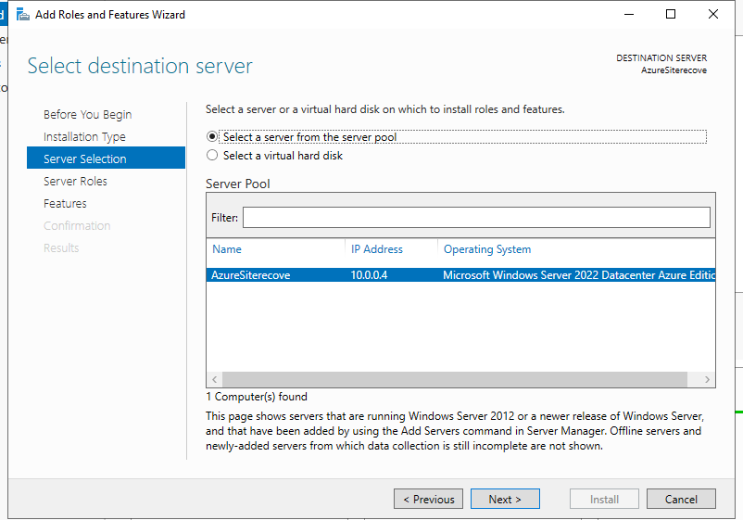

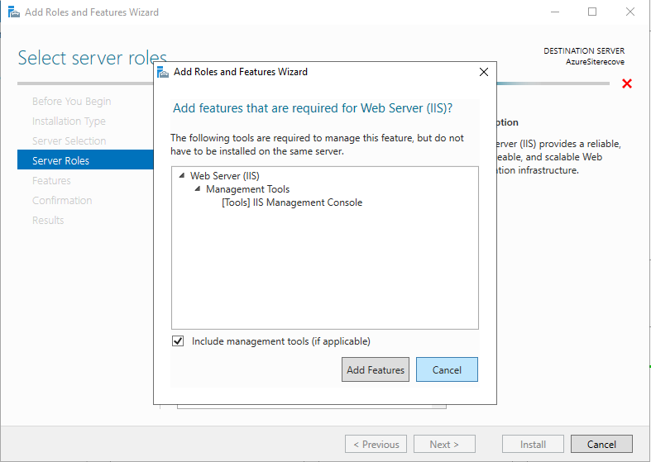

Here are screenshots of me downloading Webserver IIS so that the IP address can be seen publicly in my VM or even in a regular internet browser. The last screenshot shows the IP from my VM being used in an internet browser.

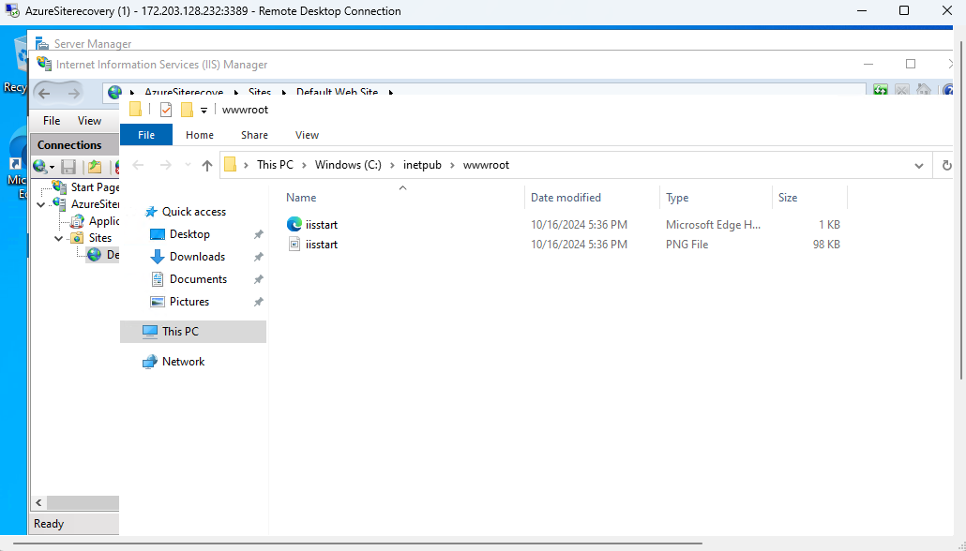

Here you see that I have went into the server manager IIS file to start up my site recovery. I will go to start up on the iistart file which is associated with Microsoft edge

Here you see I have edited the html associated with my VM. The h1 setting with my name on it is what I have edited it to. It will now be visible on the internet browser.

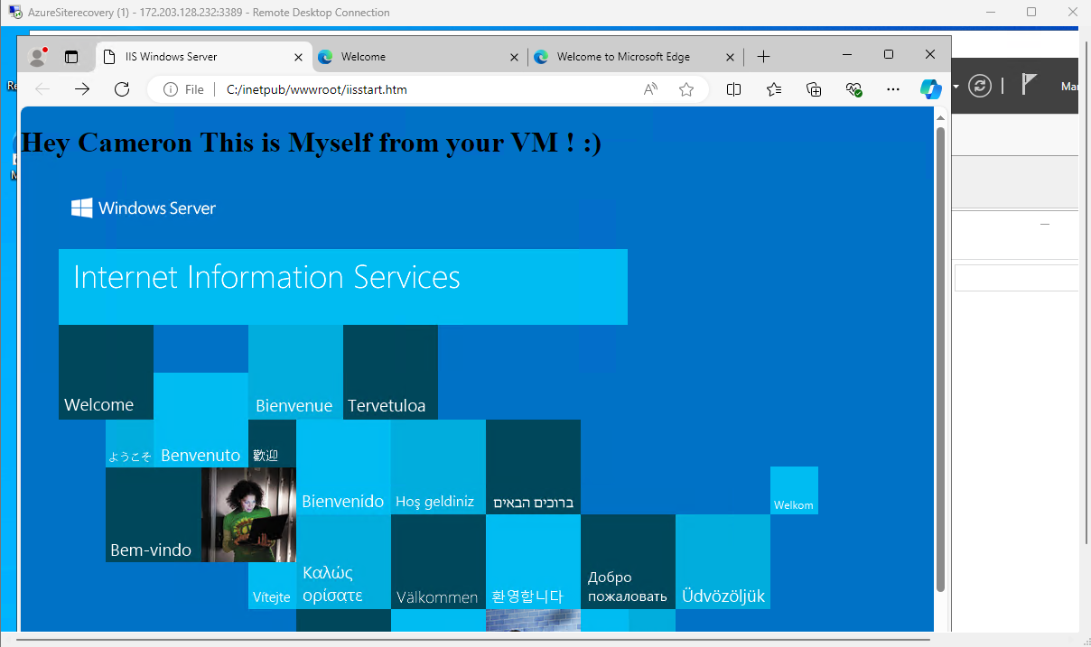

This is a screenshot of the edited html internet browser with my name associated inside the VM.

I have created an inbound security rule so that the same edited html can appear on an internet publicly outside of my VM.

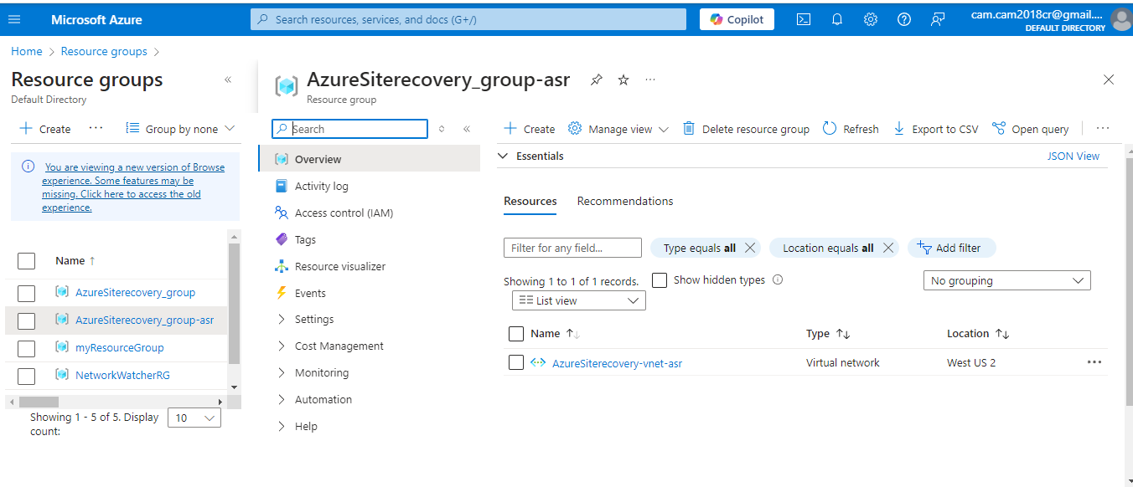

Here you see a resource group was created name AzureSiterecovery_group asr. It will be a new VM created.

Here you see 3 things here which is in the same region as my source environment is in.

Replication has been successfully completed fo my VM.

Here is an overlook of the site recovery jobs.